WORKBOOK ASSIGNMENT-4

QUESTION1
Q1) Create a MySQL database named CollegeDB and create the following tables:
Ans: Query:
-- Create Database
CREATE DATABASE SeniorCollegeDB;
USE SeniorCollegeDB;

-- Create Student Table
CREATE TABLE Student (
StudentID INT PRIMARY KEY,
StudentName VARCHAR(50),
City VARCHAR(30)
);

-- Create Course Table
CREATE TABLE Course (
CourseID INT PRIMARY KEY,
CourseName VARCHAR(50),
Fees DECIMAL(10,2)
);

-- Create Enrollment Table
CREATE TABLE Enrollment (
EnrollmentID INT PRIMARY KEY,
StudentID INT,
CourseID INT,
EnrollmentDate DATE,
FOREIGN KEY (StudentID) REFERENCES Student(StudentID),
FOREIGN KEY (CourseID) REFERENCES Course(CourseID)
);
Output:
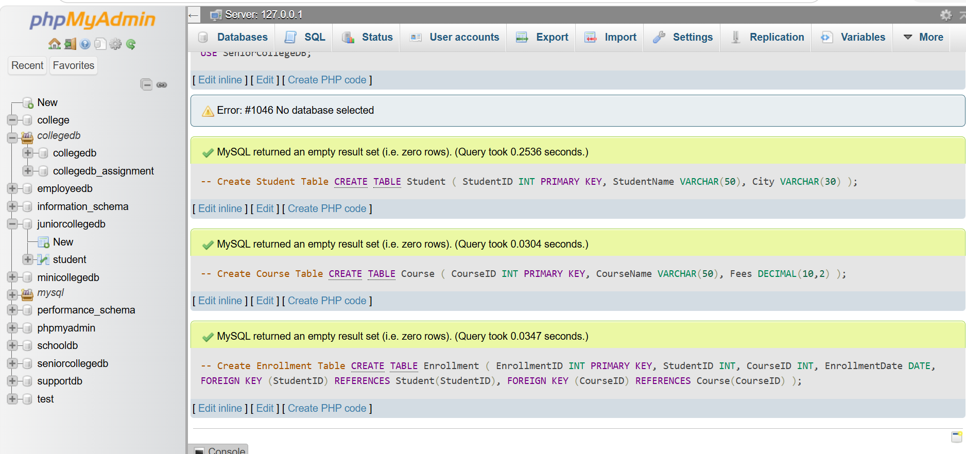

QUESTION2
Q2) Insert at least 6 records into the Student table, 4 records into the Course table, and 5 records into the Enrollment table. Make sure:
Requirement
At least one student should not have enrollment
At least one course should not have any enrolled student
Ans: Query:
-- Insert into Student table
INSERT INTO Student VALUES
(1, 'Alice', 'NY'),
(2, 'Bob', 'LA'),
(3, 'Charlie', 'SF'),
(4, 'Dave', 'CHI'),
(5, 'Eve', 'MIA'),
(6, 'Frank', 'SEA');

-- Insert into Course table
INSERT INTO Course VALUES
(101, 'Math', 500.00),
(102, 'Science', 600.00),
(103, 'Art', 300.00),
(104, 'History', 400.00);

-- Insert into Enrollment table
INSERT INTO Enrollment VALUES
(1001, 1, 101, '2023-01-01'),
(1002, 2, 101, '2023-01-02'),
(1003, 3, 102, '2023-01-03'),
(1004, 4, 103, '2023-01-04'),
(1005, 5, 103, '2023-01-05');
Output:
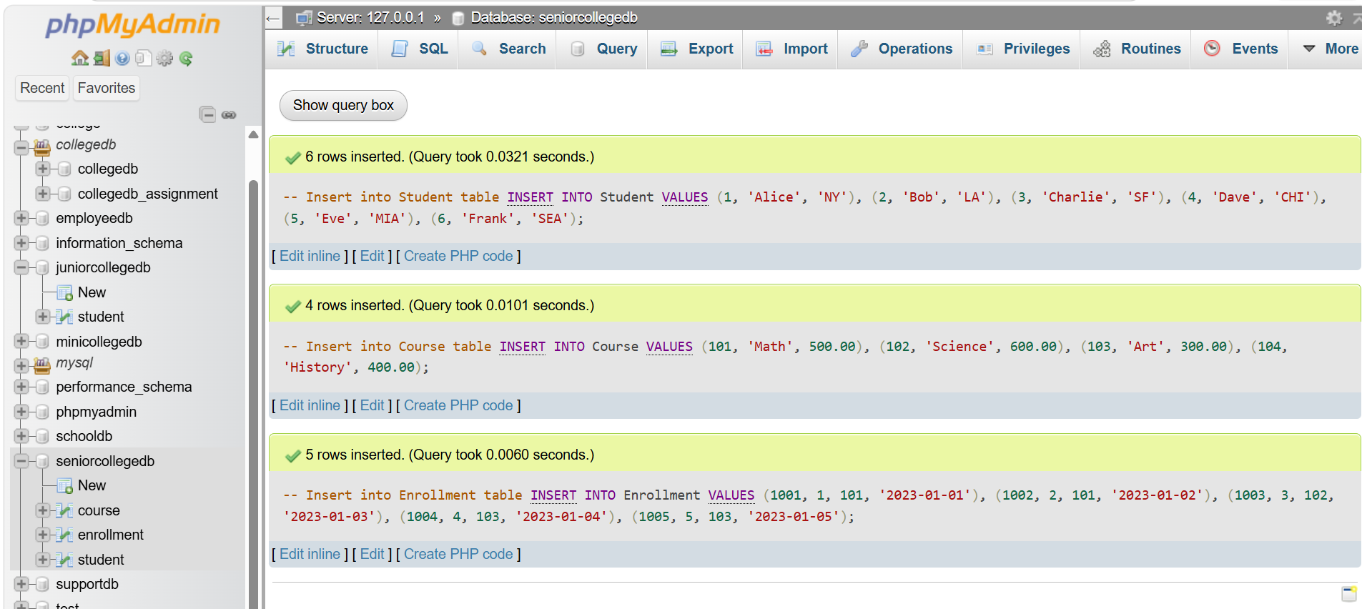
QUESTION3
Q3) Write a MySQL query using INNER JOIN to display students who have enrolled in courses. The output should include:
Column
StudentID
StudentName
CourseID
EnrollmentDate
Ans: Query:
SELECT Student. StudentID,
Student. StudentName,
Enrollment. CourseID,
Enrollment. EnrollmentDate
FROM Student
INNER JOIN Enrollment ON
Student. StudentID =
Enrollment. StudentID;
Output:
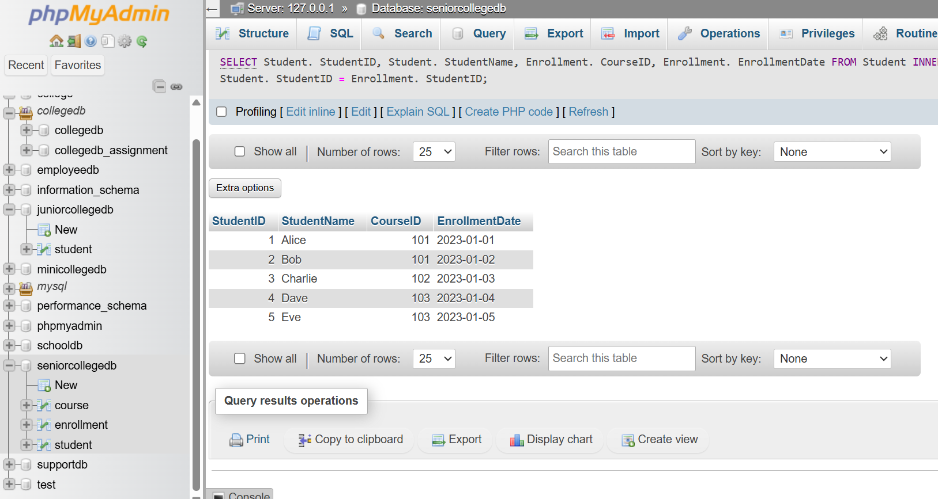

QUESTION4
Q4) Write a MySQL query to display student name, city, course name, fees, and enrollment date using multiple tables. Use:
Tables Required
Student
Course
Enrollment
Ans:
Query:
SELECT Student. StudentName,
student. city,
Course. CourseName,
Course. Fees,
Enrollment. EnrollmentDate
FROM Student
JOIN Enrollment ON
Student. StudentID =
Enrollment. StudentID
JOIN Course ON Enrollment. CourseID
= Course. CourseID;
Output:
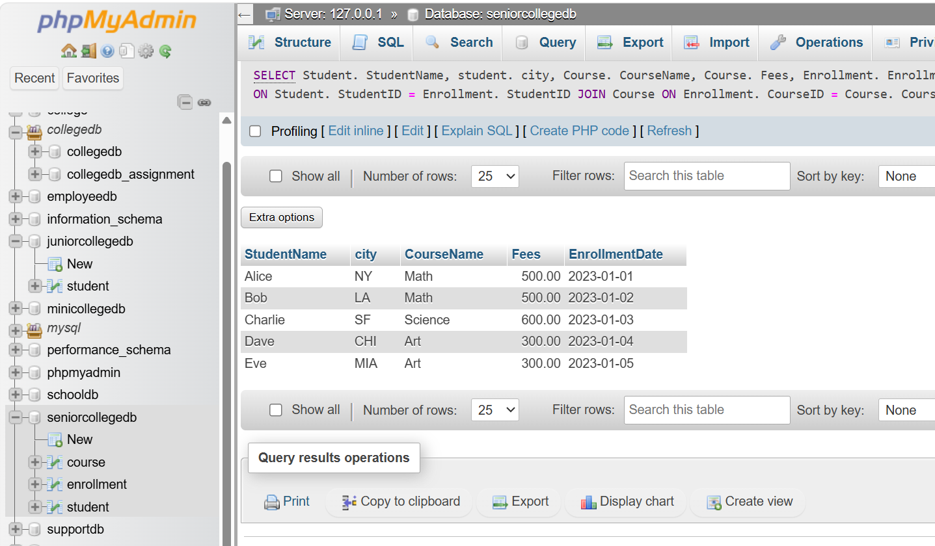

QUESTION5
Q5) Write a MySQL query using LEFT JOIN to display all students, including those who have not enrolled in any course. The output should include:
Column
StudentID
StudentName
City
CourseID
EnrollmentDate
Ans: Query:
SELECT Student. StudentID,
Student. StudentName,
Student. City,
Enrollment. CourseID,
Enrollment. EnrollmentDate
FROM
Student
LEFT JOIN Enrollment
ON Student.StudentID = Enrollment.StudentID;
Output:
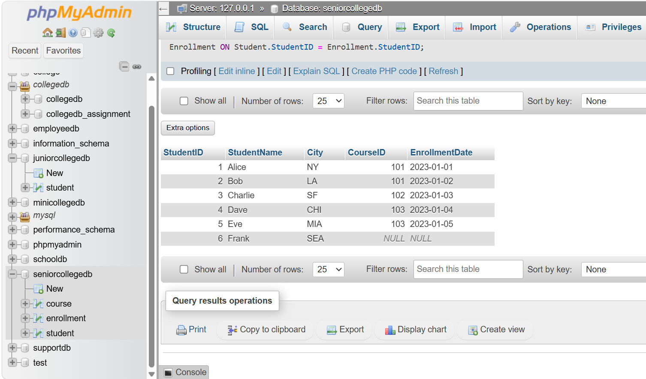

QUESTION6
Q6) Write a MySQL query using RIGHT JOIN to display all courses, including courses that have no enrolled students. The output should include:
Column
StudentName
CourseID
CourseName
Fees
Ans: Query:
SELECT Student.StudentName,
Course. CourseID,
Course. CourseName,
Course. Fees
FROM Student
JOIN Enrollment ON
Student.StudentID = Enrollment.StudentID
RIGHT JOIN Course ON
Enrollment. CourseID = Course. CourseID;

Output:
